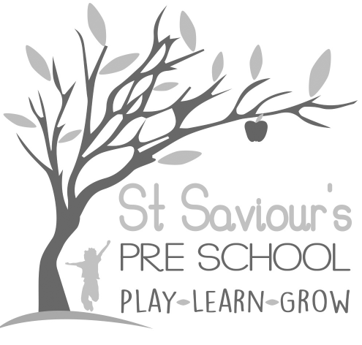
3.2 FIRST AID

Written by: Claire Toms and Tina Alder Date: 1.09.22. – reviewed 28.8.25

Policy Statement
We can take action to apply first aid treatment in the event of an accident involving a child or adult. At least one adult with a current first aid certificate is on the premises, or on an outing, at any one time. The first aid qualification includes first aid training for infants and young children. All paediatric first aid training must meet the criteria set out in the EYFS 2025 and be delivered by a regulated training provider. We aim to ensure that first aid training is up to date, evidence-based, and relevant to adults caring for babies and young children.

Procedures
- Information about who has completed first aid training and the location of the first aid box is provided to all our staff and volunteers and displayed in the setting. Training must be updated every 3 years, in line with statutory requirements.
- All newly qualified staff who hold a Level 2 or Level 3 childcare qualification must have a valid Paediatric First Aid (PFA) certificate before they can be included in ratios, as required by EYFS 2025.
- At least one paediatric first aid trained practitioner must be available on site at all times and must accompany children on outings, including lunch club and outdoor activities.
- The first aid box is easily accessible to adults and is kept out of the reach of children.
- There is a named person in the setting who is responsible for checking and replenishing the first aid box contents monthly (or sooner if supplies are used), ensuring compliance with Health and Safety Executive guidance.
- Medication is only administered in line with our Administering Medicines Policy and in accordance with EYFS 2025 requirements for parental consent, storage, and record-keeping.
- In the case of minor injury or accidents, first aid treatment is given by a qualified first aider and recorded in the Accident Book. A senior member of staff must be consulted if any injury is causing concern, or the child is unduly upset or subdued.
- Staff must wear PPE when dealing with bodily fluids and the area should be cleaned with hot water and disinfectant in line with infection control guidance.
- In the event of minor injuries or accidents, we normally inform parents when they collect their child, unless the child is unduly upset, or we have concerns about the injury. In such cases, we will contact the child’s parents for clarification of what they would like to do, i.e., whether they wish to collect the child and/or take them to their own GP.
- In the rare event of a child requiring emergency treatment, an ambulance will be called. We contact parents immediately and inform them of what has happened and where their child has been taken.
- Accidents and injuries are recorded in our accident record book and signed by the practitioner, and the parent. Where applicable, the Health and Safety Executive, Ofsted and/or local child protection agencies may be informed.
- Serious accidents, injuries, or deaths must be reported to Ofsted and the local child protection team within 14 days, in line with EYFS 2025 statutory requirements.

